**Experiment 4: To Perform various line coding formats for given digital data**

**streams compare performance parameters.**

**Apparatus:** Multisim

**Theory:**

**Theory of Data Formatting**

The symbols ‘0’ and ‘1’ in digital systems can be represented in various formats with different levels & waveforms. The selection of particular format for communication depends on the system bandwidth, system’s ability to pass DC level information, error checking facility, ease of clock regeneration & synchronizations at receiver, system complexity & cost etc. The most widely used formats of data representation are given below. These are also available on ST2156 trainer. Every data format has specific advantages & disadvantages associated with them. We will study one by one see figure 1.

**Non - Return To Zero (Level) NRZ (L) :**

It is the simplest form of data representation. The NRZ (L) waveform simply goes low for one bit time to represent a data '0' & high for one bit time to represent a data '1'. Thus the signal alternates only when there is a data change. See figure 2.

**Clock Regeneration:**

Since the level transition takes place at a predetermined moment (e.g. at rising/falling edge of the data clock), it is possible to extract clock information at the receiver. However the synchronization & clock information is sparse & sometimes even lost when a long stream of zero or ones are encountered. The clock regeneration is very difficult in such cases. This makes the clock regeneration design more complex.

**Bandwidth:**

The maximum rate at which NRZ (L) waveform can change is half the data clock. This happens when the data stream consists of an alternate 0's and 1's. As it is known, it is the maximum signal frequency which determines the bandwidth occupied by the NRZ (L) code. As you will study other data formats you will appreciate that the NRZ (L) waveform requires comparatively narrow bandwidth.

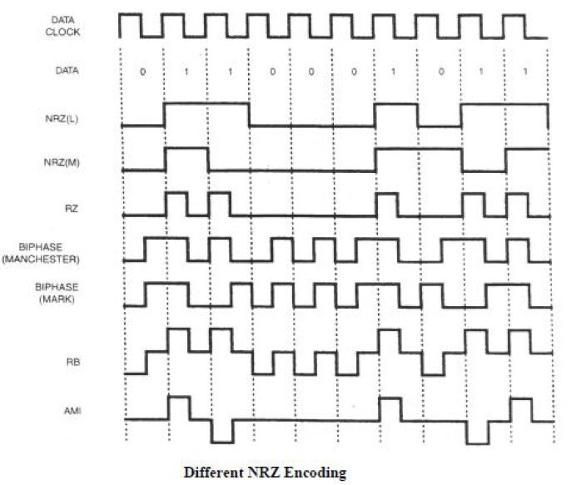

**Figure 1.**

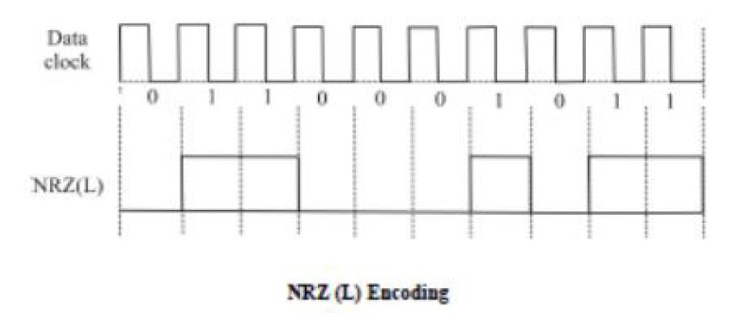

**DC Levels:**

Another problem with NRZ (L) code is that it contains DC Level hence cannot be used for communication systems which cannot pass DC. e.g. transmission paths involving transformers AC coupled amplifiers or series capacitors filters etc. This happens particularly in telephone systems.

Let us see now an NRZ (L) code is rendered useless in such systems. Assume a sequence of repetitive data sent is 0110001 with data 1 level at + 5V & data '0' at 0V. If the DC Level is lost, the waveform balances at the mean level.

Mean level = total value of samples ÷ no of samples.

= (0+5+5+0+0+0+5) ÷ 7 = 15 ÷ 7 = 2.14V

Thus if the DC Level information is lost, the whole signal balances about 2.14V. Thus the peak value of + 5V will shift to 5 - 2.14 = 2.86V

It may slip down to a level where the receiver cannot recognize as level '1' & thus the data could be misread. In extreme case where the input is constant series of logic 0's then the NRZ (L) output would be a constant level. Now if the input changed to a stream of logic 0's, the output would still be a constant level. The only difference is the DC Level. Therefore if the DC Level information is lost, we have no way of knowing whether the original input will have all 0's or all 1's.

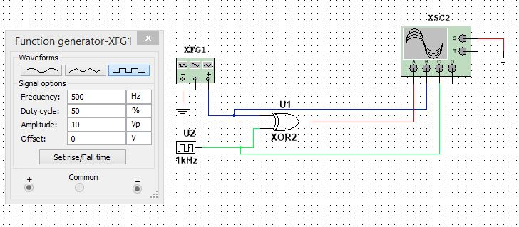

**Multisim Simulation Circuit:**

**Procedure:**

**Step-1**

Connect the circuit as per the figure above.

Observe the output.

**Step-2**

Change the frequency of XFG1 as last two digits of your enrollment no.

Observe the output.

**OUTPUT:**

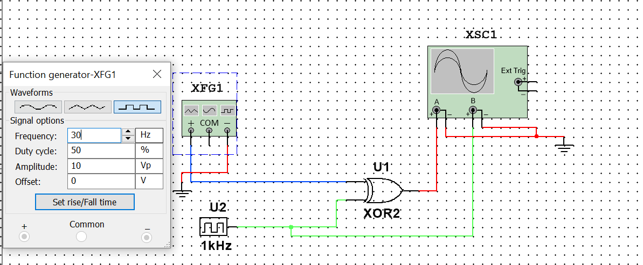

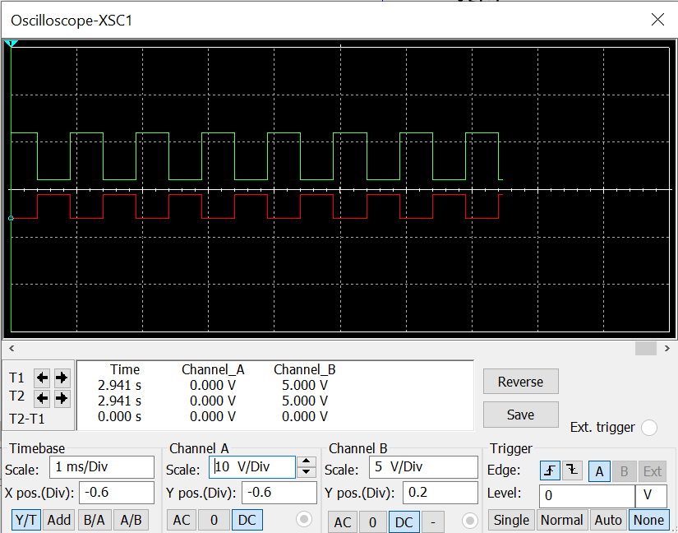

**Observation:**

**Conclusion:**

**Experiment No 4: Post Lab Exercise**

**Q.1 Identify the correct line coding scheme and write in the given block.**

